Project Design Phase-II
Data Flow Diagram & User Stories

Date | 30 September 2026
Team ID | MKU201Team66ab4dee00fc666a751b56cd7
Project Name | Script-Controlled ACL – Restrict Record Access Based on Field Value
Maximum Marks | 4 Marks
Data Flow Diagrams:
A Data Flow Diagram (DFD) is a traditional visual representation of the information flows within a system. A neat and clear DFD can depict the right amount of the system requirement graphically. It shows how data enters and leaves the system, what changes the information, and where data is stored.
Example: (Simplified)  Flow  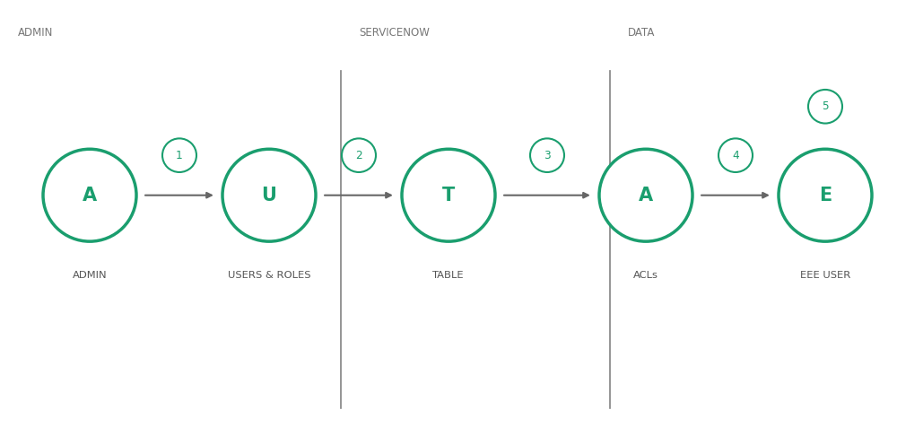  1. Admin logs in to the ServiceNow instance and creates the EEE User.  2. Admin creates the roles bb1, bb2, bb3, bb4 and assigns them to the EEE User.  3. Admin creates the Institution Details table (u_institution_details) with its fields and branch records.  4. Admin creates the Read, Create, Write and Delete ACLs with the required roles and the read script.  5. EEE User is impersonated; the ACL checks role and Branch value and shows only the permitted records. | 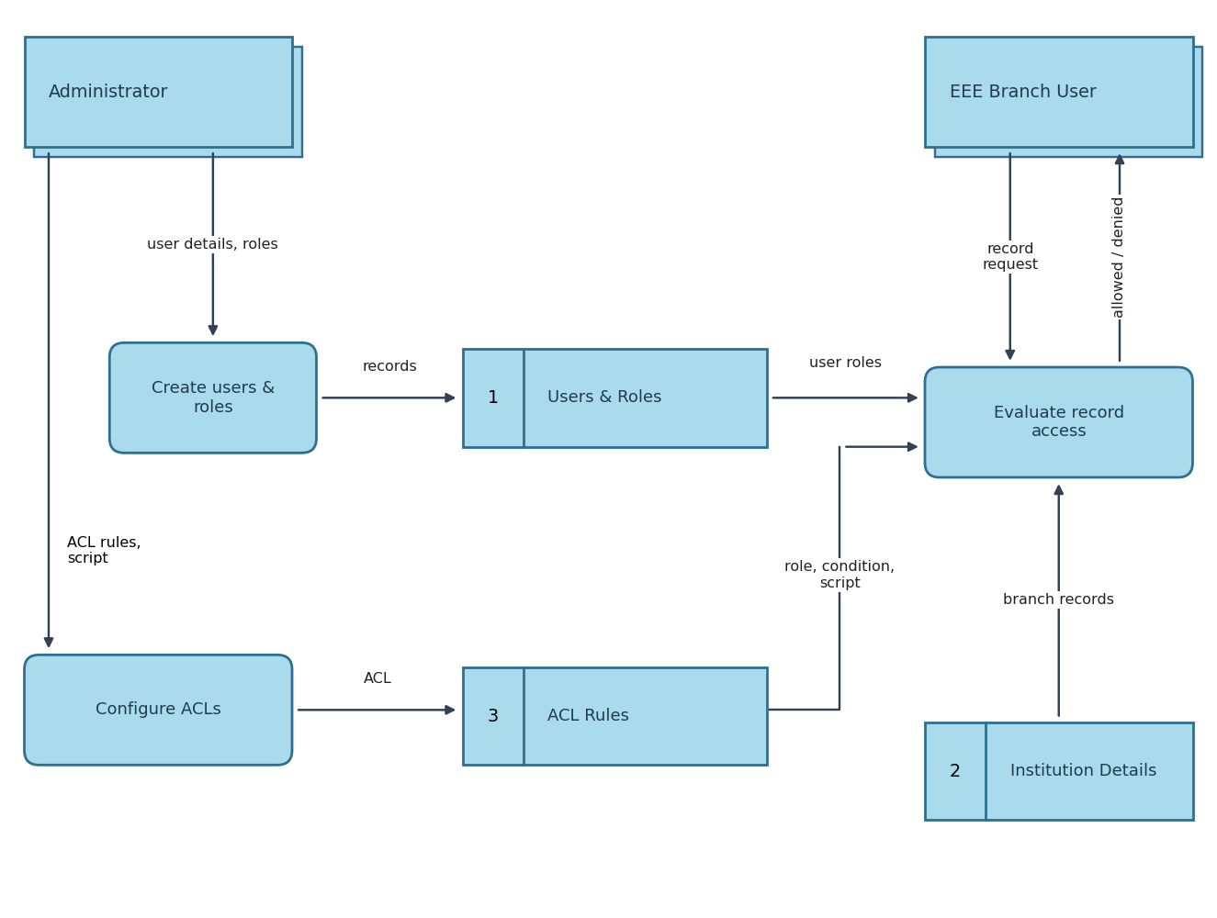
  Example: DFD Level 0 (Industry Standard)

User Stories
Use the below template to list all the user stories for the product.
User Type | Functional Requirement (Epic) | User Story Number | User Story / Task | Acceptance criteria | Priority | Release
Administrator | Users & Roles Creation | USN-1 | As an administrator, I can create the EEE User by entering user ID, first name, last name and email. | User record is saved and appears in the Users list | High | Sprint-1
Administrator | Users & Roles Creation | USN-2 | As an administrator, I can create the roles bb1, bb2, bb3 and bb4 and assign all of them to the EEE User. | Roles are listed on the EEE User record | High | Sprint-1
Administrator | Table Creation | USN-3 | As an administrator, I can create the Institution Details table (u_institution_details) with fields for roll number, student, faculty, branch, email, phone and description. | Table and fields are saved; records for ECE, EEE and CSE can be created | High | Sprint-1
Administrator | ACL Configuration | USN-4 | As an administrator, I can create a script-controlled Read ACL with the Branch is EEE condition and the bb1 role. | ACL is active and saved on u_institution_details | High | Sprint-2
Administrator | ACL Configuration | USN-5 | As an administrator, I can create Create, Write and Delete ACLs that require the roles bb2, bb3 and bb4. | Three ACLs are saved with the matching roles and no data condition | Medium | Sprint-2
Administrator | Record Access | USN-6 | As an administrator, I can view all records regardless of branch. | Admin sees ECE, EEE and CSE records in the list | High | Sprint-2
EEE Branch User (role bb1) | Record Access (Read) | USN-7 | As an EEE branch user with the bb1 role, I can view only the records where Branch is EEE. | List shows only EEE branch records | High | Sprint-2
EEE Branch User (role bb1) | Record Access (Read) | USN-8 | As a user without the bb1 role, I cannot view any records. | The Institution Details list is empty | High | Sprint-2
Record Creator (role bb2) | Record Creation | USN-9 | As a user with the bb2 role, I can create new records in the Institution Details table. | New record is created and saved | Medium | Sprint-3
Record Editor (role bb3) | Record Update | USN-10 | As a user with the bb3 role, I can update existing records in the Institution Details table. | Changes are saved on the record | Medium | Sprint-3
Record Deleter (role bb4) | Record Deletion | USN-11 | As a user with the bb4 role, I can delete records from the Institution Details table. | Record is removed from the list | Low | Sprint-3

